SARDAR VALLABHBHAI NATIONAL INSTITUTE OF TECHNOLOGY, SURAT
DEPARTMENT OF CIVIL ENGINEERING
STRUCTURAL ENGINEERING SECTION
CONCRETE TECHNOLOGY LABORATORY
Concrete Technology Laboratory was established in 1961. The laboratory is located behind the Department of Civil Engineering Wing II. Undergraduate and postgraduate students utilize laboratory facilities for their curriculum laboratory work. Ph.D. Research scholars also utilize it for research purposes. Set-up like Universal Testing Machine, Concrete Pan Mixer, Concrete Drum Mixer, Compression Testing Machine, and Vibration Table is used for consultancy work and UG/PG students. It is one of the key laboratory for UG/PG students. The laboratory has good potential to carry out research and generate revenue using testing work. The list of equipment available in the laboratory is given below:
Sr. No. | Equipment Name
1 | Universal Testing Machine 1200kN capacity
2 | Steam Curing Chamber
3 | Industrial Drying Oven
4 | Flow Table
5 | Humidity Chamber
6 | Mortar Mixer Machine
7 | Vicat Apparatus
8 | Muffle Furnace
9 | Hot Water Bath
10 | Concrete Drum Mixer Machine
11 | Drilling Machine
12 | Lathe Machine
13 | Tiles abrasion testing machine
14 | Compression Testing Machine
15 | Automatic Compression Testing Machine
16 | Universal Testing Machine
17 | Permeability Apparatus
18 | Digital Compression Testing Machine
19 | Concrete Pan Mixer
20 | Vibrating Table
Information Regarding Few Important Set-ups in the Concrete Technology Laboratory
Universal Testing Machine:
A Universal testing machine (UTM) tests the mechanical properties (tension, compression, etc.) of the specimen by using tensile, compressive, or transverse stresses. The machine has been named so because of its wide range of tests over different materials. Different tests, like peel, flexural, tension, bend, friction, spring, etc., can be performed with the help of UTM. UTM is depicted in Figure 1 and 2.
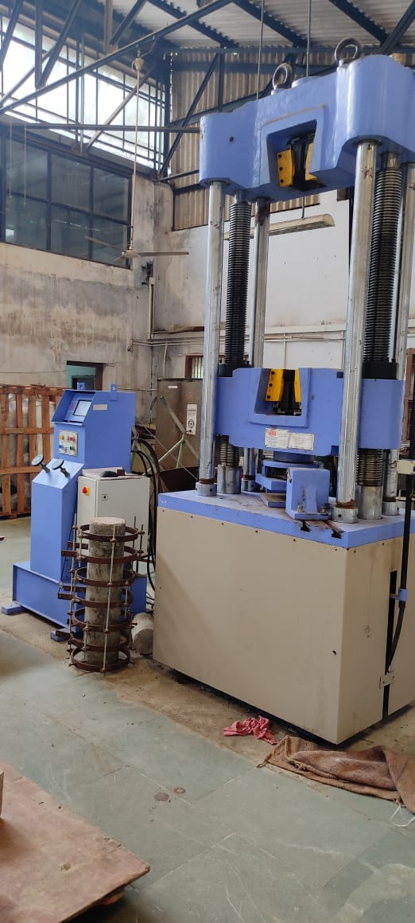
Figure.1 Digital Universal Testing Machine
Figure 2. Analog Universal Testing Machine

Concrete Mixer
A concrete mixer is a device that combines cement, aggregate such as sand or gravel, and water to form concrete. A typical concrete mixer uses a revolving drum to mix the components. The drum mixer is used for the normal-strength concrete, and the concrete pan mixer machine is used to mix the high-strength concrete. The concrete drum mixer and Pan mixer are shown in Figures 3 and 4.
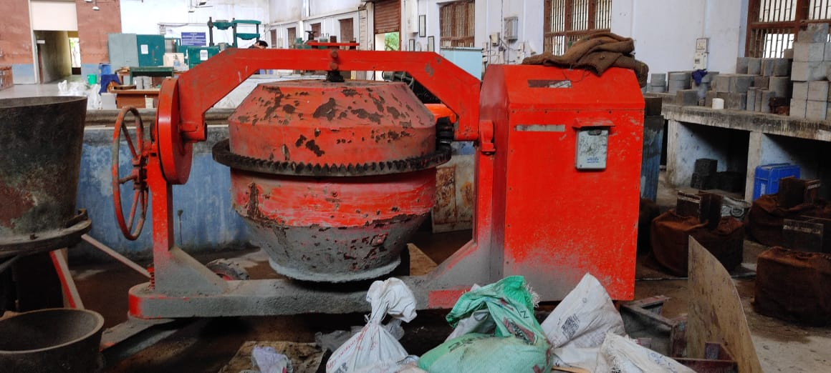
Figure 3. Concrete Drum Mixer
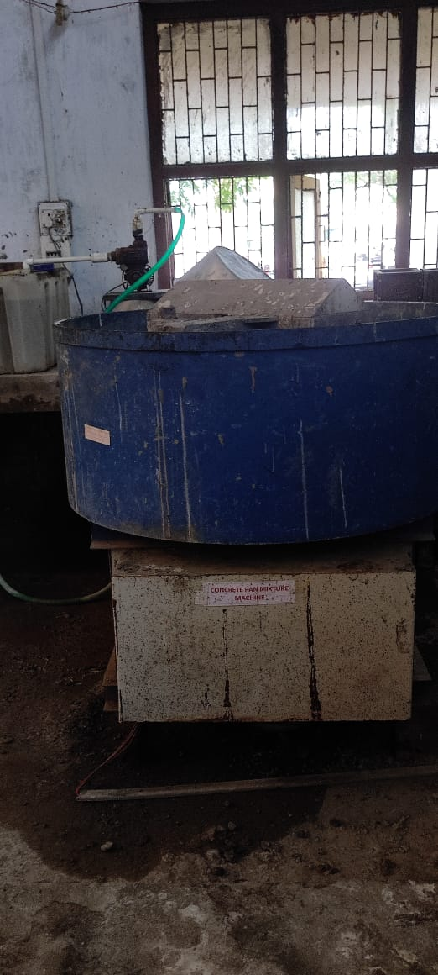
Figure 4. Concrete Pan Mixer

Flow Table
Flow tables are used to determine consistency (flow) and to prepare mortars of standard consistency for testing. Flow is determined as a percent increase in the diameter of a conically molded mortar. The flow table is shown in figure 5.
Figure 5. Flow Table

Humidity Chamber
Humidity test chambers, also known as humidity cabinets, create the required conditions for the stability testing of various materials. A humidity test chambers can be used to simulate various temperature and humidity conditions.
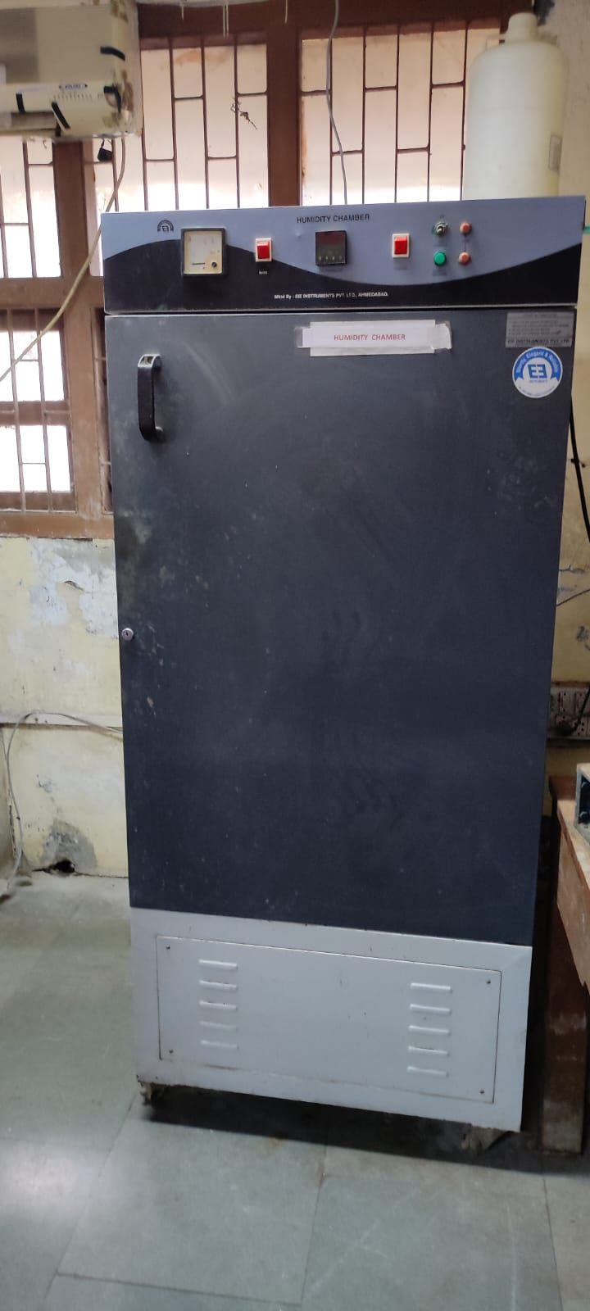
Figure 6. Humidity Chamber
Mortar Mixer Machine
The cement mortar machine is used to mix the cement and sand homogeneously to find the compressive strength of the cement mortar. Two different modes (Slow and Fast) are available and used accordingly.
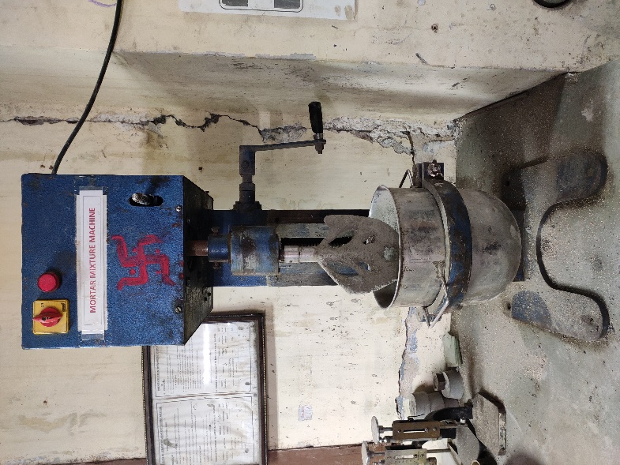
Figure 7. Mortar Mixer
Mortar Vibrator
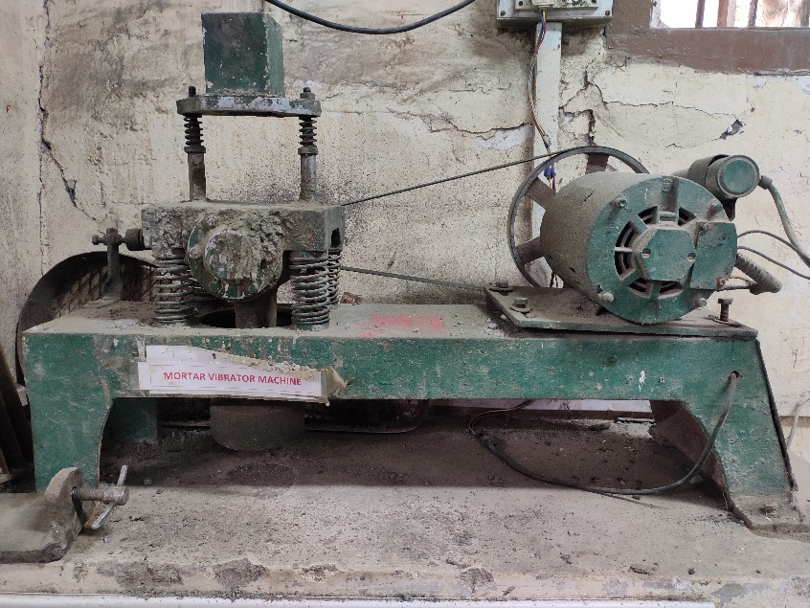
Figure 8. Mortar Vibrator
LIST OF EXPERIMENTS
Concrete Technology (B. Tech-II (Civil), Semester III)
Sr. No. | Title of Experiment
1 | To determine fineness of cement.
2 | To determine initial and final setting time of cement.
3 | To determine soundness of cement.
4 | To determine compressive strength of cement.
5 | To determine mechanical properties of fine aggregates.
6 | To determine mechanical properties of coarse aggregates.
7 | To design a concrete mix of two different grades.
8 | To determine workability of concrete and study of effect of super-plasticizers on it.
9 | To determine setting time of concrete
10 | To conduct destructive and non-destructive tests on standard concrete cubes.
11 | To determine elastic modulus and split tensile strength of concrete.
12 | To determine flexural strength of plain concrete.

Photos of Some Other UG/PG Set Ups
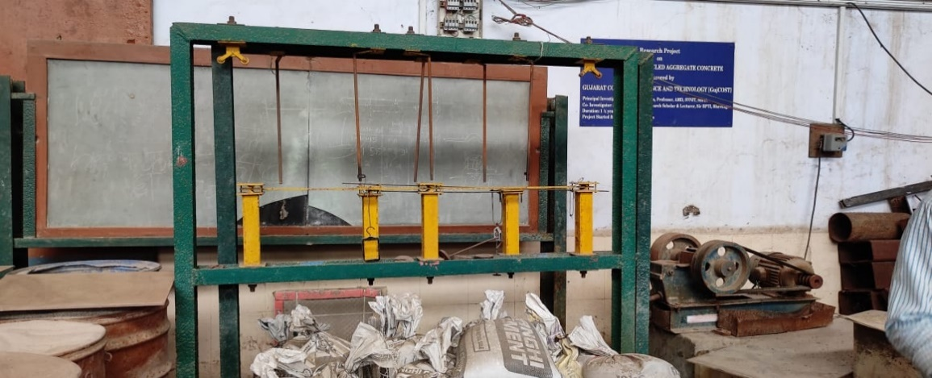
Split Tensile Strength

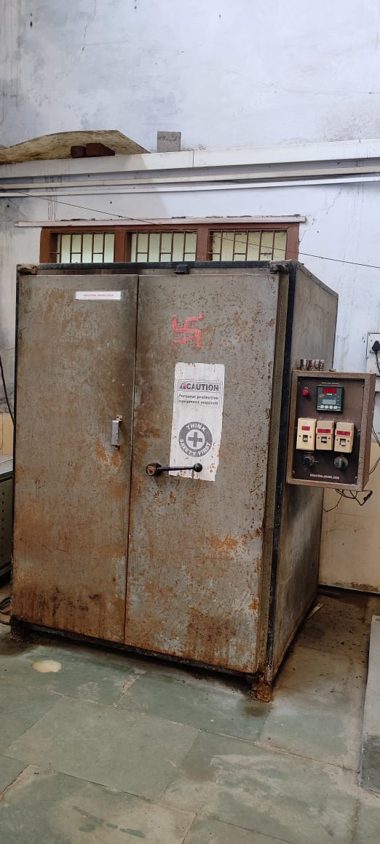
Industrial drying oven
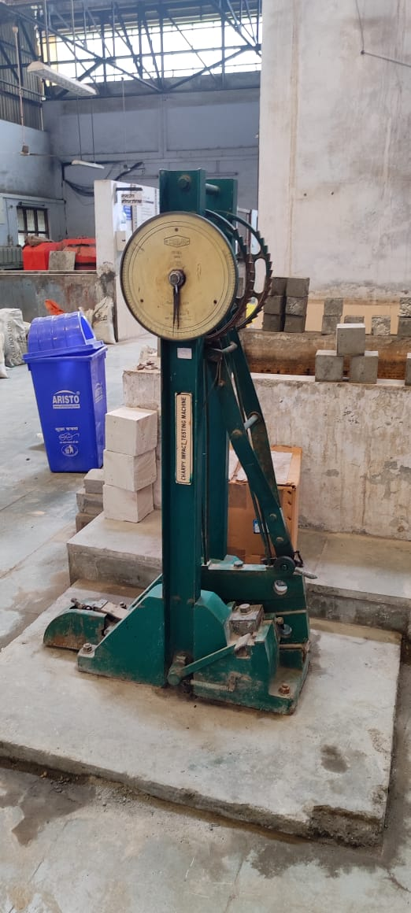
Charpy Impact Testing machine

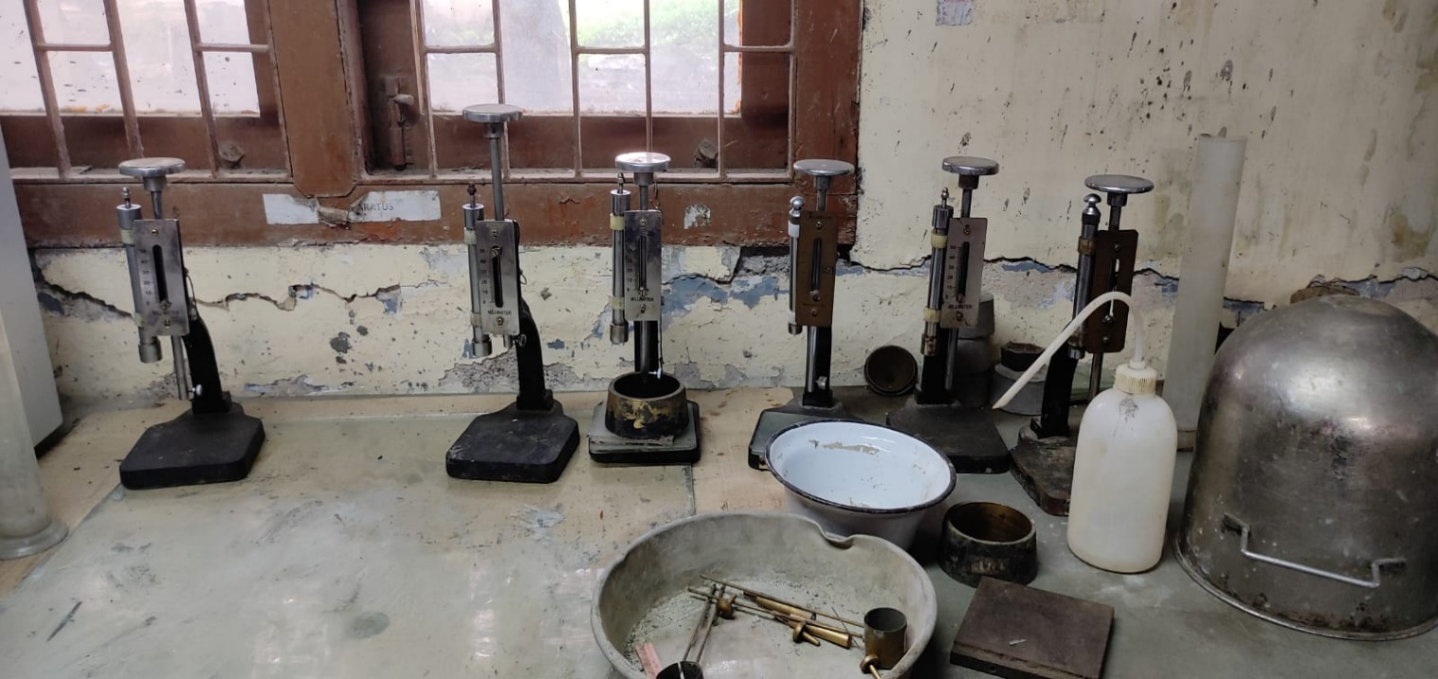
Vicat Apparatus
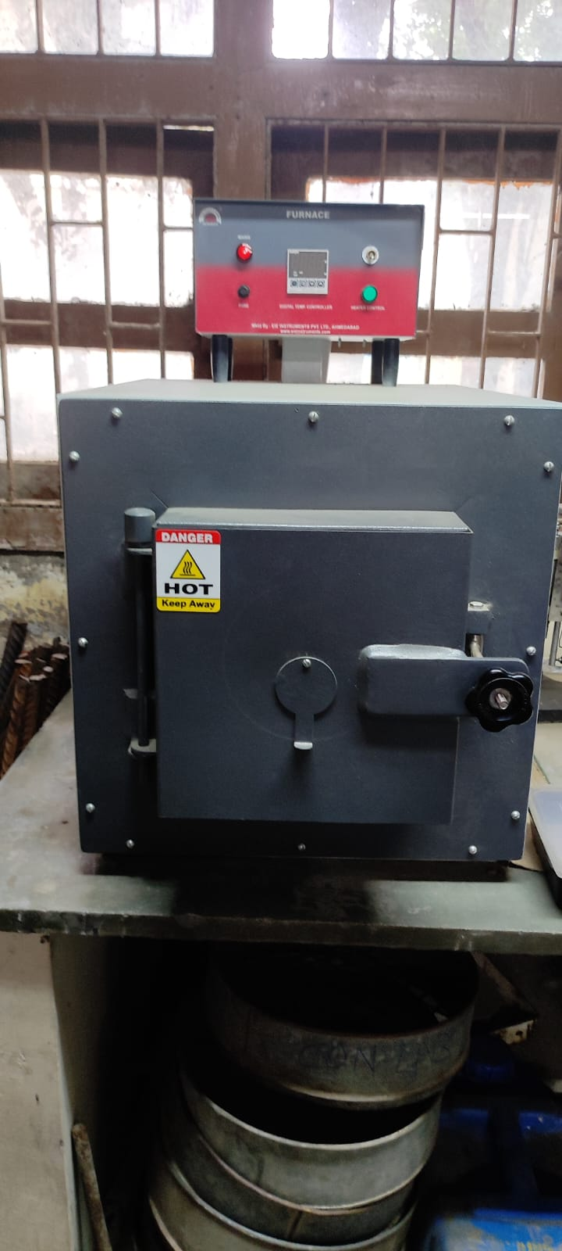
Muffle Furnace
Hot water bath

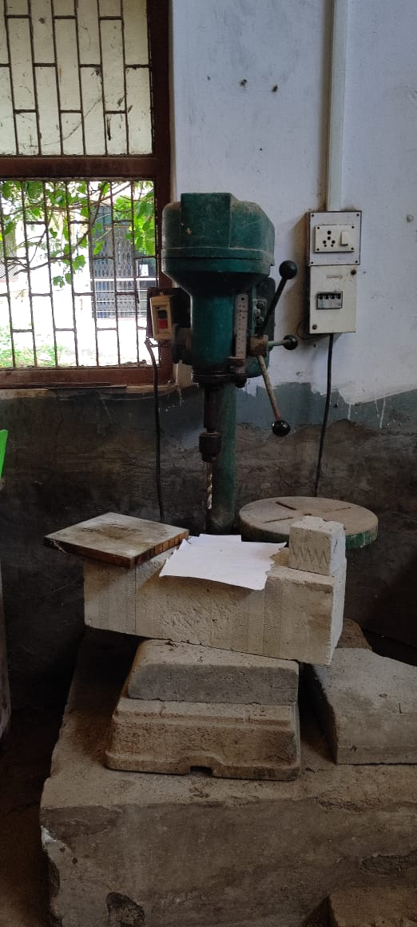
Drilling machine
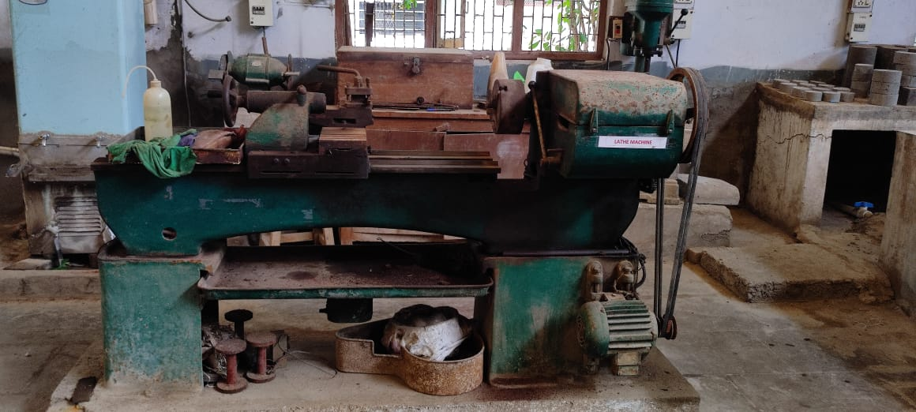
Lathe machine
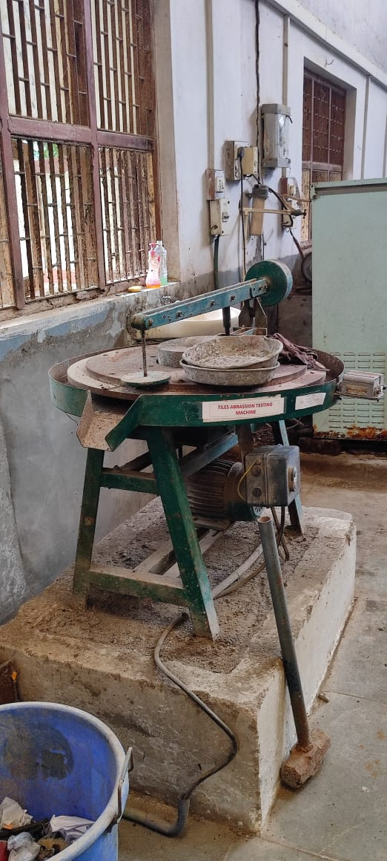
Tiles abrasion testing machine
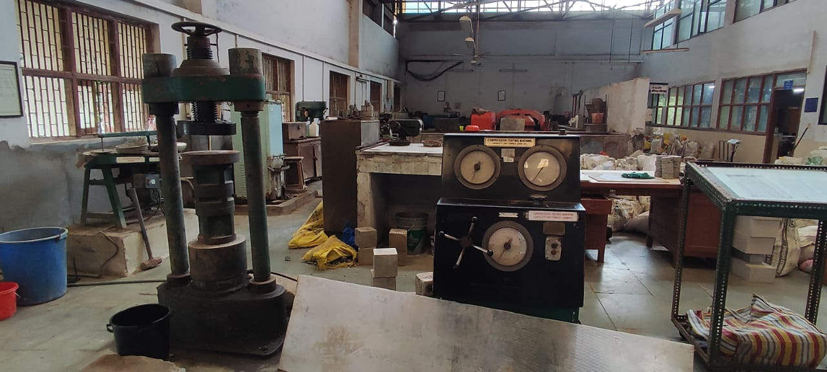
Compressive testing machine
Automatic compression testing machine
Concrete Permeability
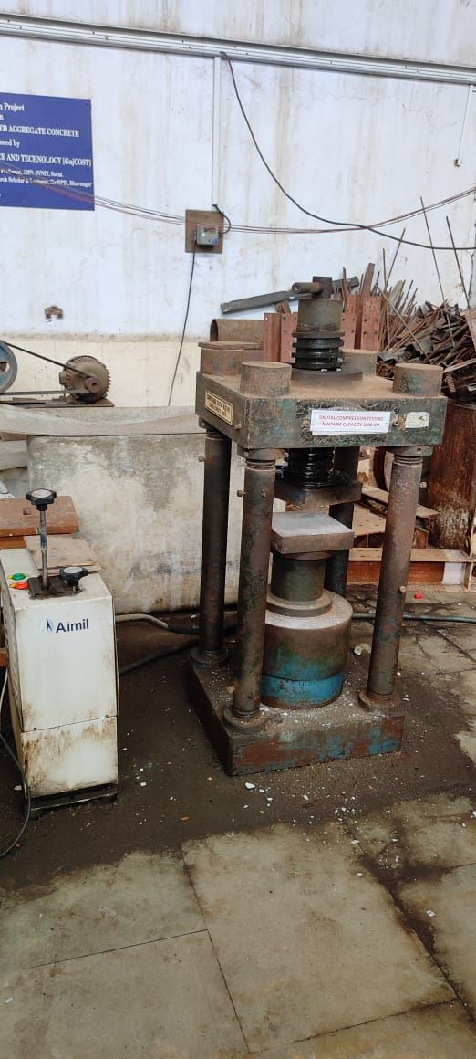
Digital compression testing machine
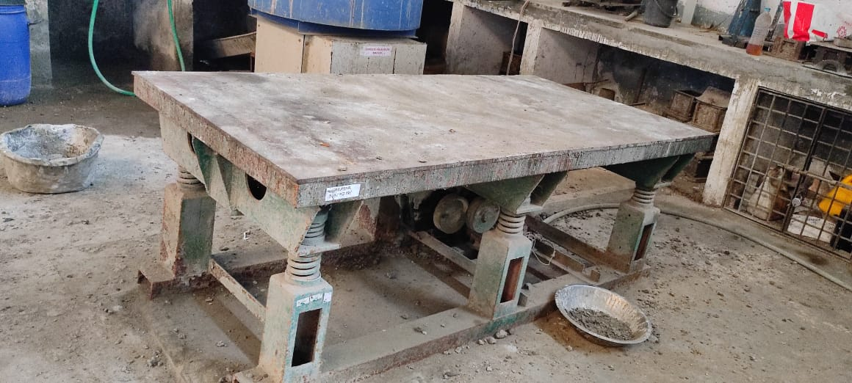
Vibrating table

